

Semester One Examination, 2021

Question/Answer booklet

MATHEMATICS  
SPECIALIST  
UNIT 3 Year 12

If required by your examination administrator, please place your student identification label in this box

Section Two:  
Calculator-assumed

|  |  |  |  |  |  |  |  |  |  |  |
| --- | --- | --- | --- | --- | --- | --- | --- | --- | --- | --- |
| WA student number: In figures |  |  |  |  |  |  |  |  |  |  |

In words

Your name

|  |  |
| --- | --- |
| Number of additional answer booklets used (if applicable): |  |

## Time allowed for this section

Reading time before commencing work: ten minutes

Working time: one hundred minutes

## Materials required/recommended for this section

***To be provided by the supervisor***

This Question/Answer booklet

Formula sheet (retained from Section One)

***To be provided by the candidate***

Standard items: pens (blue/black preferred), pencils (including coloured), sharpener,  
correction fluid/tape, eraser, ruler, highlighters

Special items: drawing instruments, templates, notes on two unfolded sheets of A4 paper, and up to three calculators, which can include scientific, graphic and Computer Algebra System (CAS) calculators, are permitted in this ATAR course examination

## Important note to candidates

No other items may be taken into the examination room. It is **your** responsibility to ensure that you do not have any unauthorised material. If you have any unauthorised material with you, hand it to the supervisor **before** reading any further.

## Structure of this paper

|  |  |  |  |  |  |
| --- | --- | --- | --- | --- | --- |
| Section | Number of questions available | Number of questions to be answered | Working time (minutes) | Marks available | Percentage of examination |
| Section One: Calculator-free | 8 | 8 | 50 | 50 | 35 |
| Section Two: Calculator-assumed | 13 | 13 | 100 | 90 | 65 |
|  | | |  | **Total** | 100 |

|  |  |  |
| --- | --- | --- |
| Markers use only | | |
| Question | Maximum | Mark |
| 9 | 6 |  |
| 10 | 7 |  |
| 11 | 5 |  |
| 12 | 8 |  |
| 13 | 7 |  |
| 14 | 7 |  |
| 15 | 7 |  |
| 16 | 8 |  |
| 17 | 8 |  |
| 18 | 6 |  |
| 19 | 8 |  |
| 20 | 6 |  |
| 21 | 7 |  |
| S2 Total | 90 |  |
| S2 Wt (×0.7222) | 65% |  |

## Instructions to candidates

1. The rules for the conduct of examinations are detailed in the school handbook. Sitting this examination implies that you agree to abide by these rules.

2. Write your answers in this Question/Answer booklet preferably using a blue/black pen.  
Do not use erasable or gel pens.

3. You must be careful to confine your answers to the specific question asked and to follow any instructions that are specific to a particular question.

4. Show all your working clearly. Your working should be in sufficient detail to allow your answers to be checked readily and for marks to be awarded for reasoning. Incorrect answers given without supporting reasoning cannot be allocated any marks. For any question or part question worth more than two marks, valid working or justification is required to receive full marks. If you repeat any question, ensure that you cancel the answer you do not wish to have marked.

5. It is recommended that you do not use pencil, except in diagrams.

6. Supplementary pages for planning/continuing your answers to questions are provided at the end of this Question/Answer booklet. If you use these pages to continue an answer, indicate at the original answer where the answer is continued, i.e. give the page number.

7. The Formula sheet is not to be handed in with your Question/Answer booklet.

Section Two: Calculator-assumed 65% (90 Marks)

This section has**thirteen** questions. Answer **all** questions. Write your answers in the spaces provided.

Working time: 100 minutes.

Question 9 (6 marks)

The graph of $f(x)=\begin{matrix}a(b-x^{2}) \\ \overline{(x-c)(x+d)}\end{matrix}$ is shown below, where $a, b, c$ and $d$ are positive constants.

The dotted lines are the asymptotes of the function.

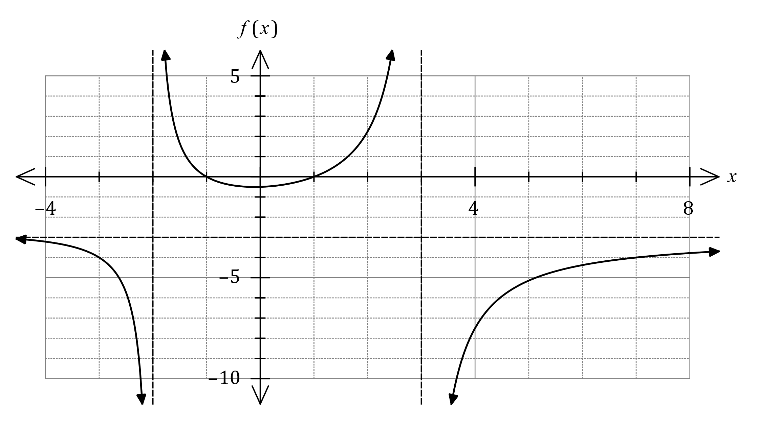

(a) Determine and write the value of each constant in the table below. (4 marks)

|  |  |  |  |  |
| --- | --- | --- | --- | --- |
| Constant | $$a$$ | $$b$$ | $$c$$ | $$d$$ |
| Value |  |  |  |  |

(b) State the equations of all asymptotes of the graph of $y=\begin{matrix}1 \\ \overline{f(x)}\end{matrix}$. (2 marks)

Question 10 (7 marks)

The arguments of the non-zero complex numbers $u$ and $v$ are $θ$ and $ϕ$ respectively, and the modulus of $u$ is twice the modulus of $v$.

Express the following in simplest form.

(a) $|u÷v|$. (1 mark)

(b) $\arg\left(iu\right)+\arg{(\overline{u})}$. (2 marks)

(c) $\begin{matrix}v\overline{v} \\ \overline{|iu|}\end{matrix}$. (2 marks)

(d) $\arg\left(\begin{matrix}\overline{uv} \\ \overline{3u^{2}}\end{matrix}\right)$. (2 marks)

Question 11 (5 marks)

The velocity vector of a particle at time $t$ seconds is given by $v\left(t\right)=\left(\begin{matrix}2t-8 \\ 5 \\ 3e^{0.5t}\end{matrix}\right)$ metres. The initial position vector of the particle is $18i+10j+2k$.

(a) Determine the displacement vector $r(t)$ for the particle after $t$ seconds. (3 marks)

(b) Determine the minimum distance of the particle from the $y$- $z$ plane. (2 marks)

Question 12 (8 marks)

(a) The locus of a complex number $z$ is the circular region shown below.

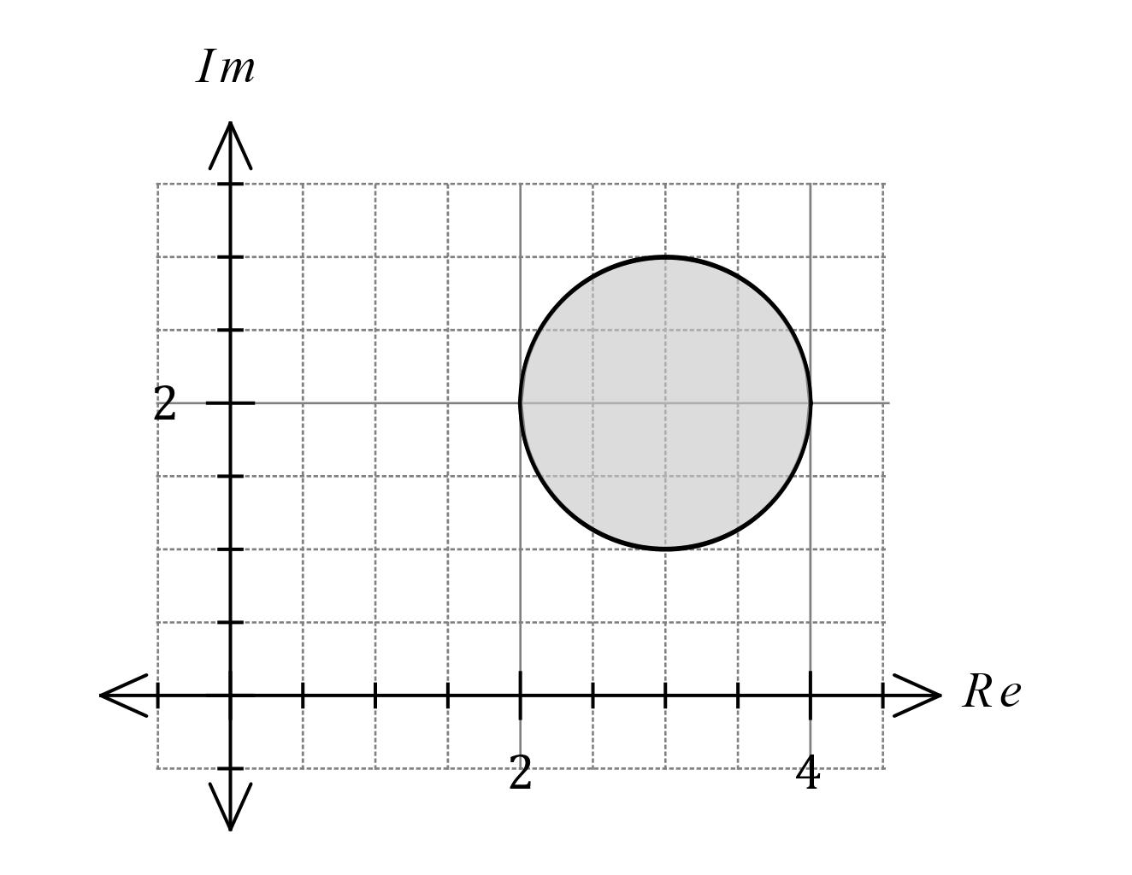

(i) Write equations or inequalities in terms of $z$ (without using $\operatorname{Re}{(z)}$ or $\operatorname{Im}\left(z\right)$) for the indicated locus. (3 marks)

(ii) Determine the minimum value for $|z-3i|$ as an exact value. (2 marks)

(b) On the complex plane below sketch the locus of the complex number $z$ determined by $-\begin{matrix}π \\ \overline{4}\end{matrix}<\arg\left(z+4-2i\right)≤\begin{matrix}π \\ \overline{4}\end{matrix}$ 
. (3 marks)

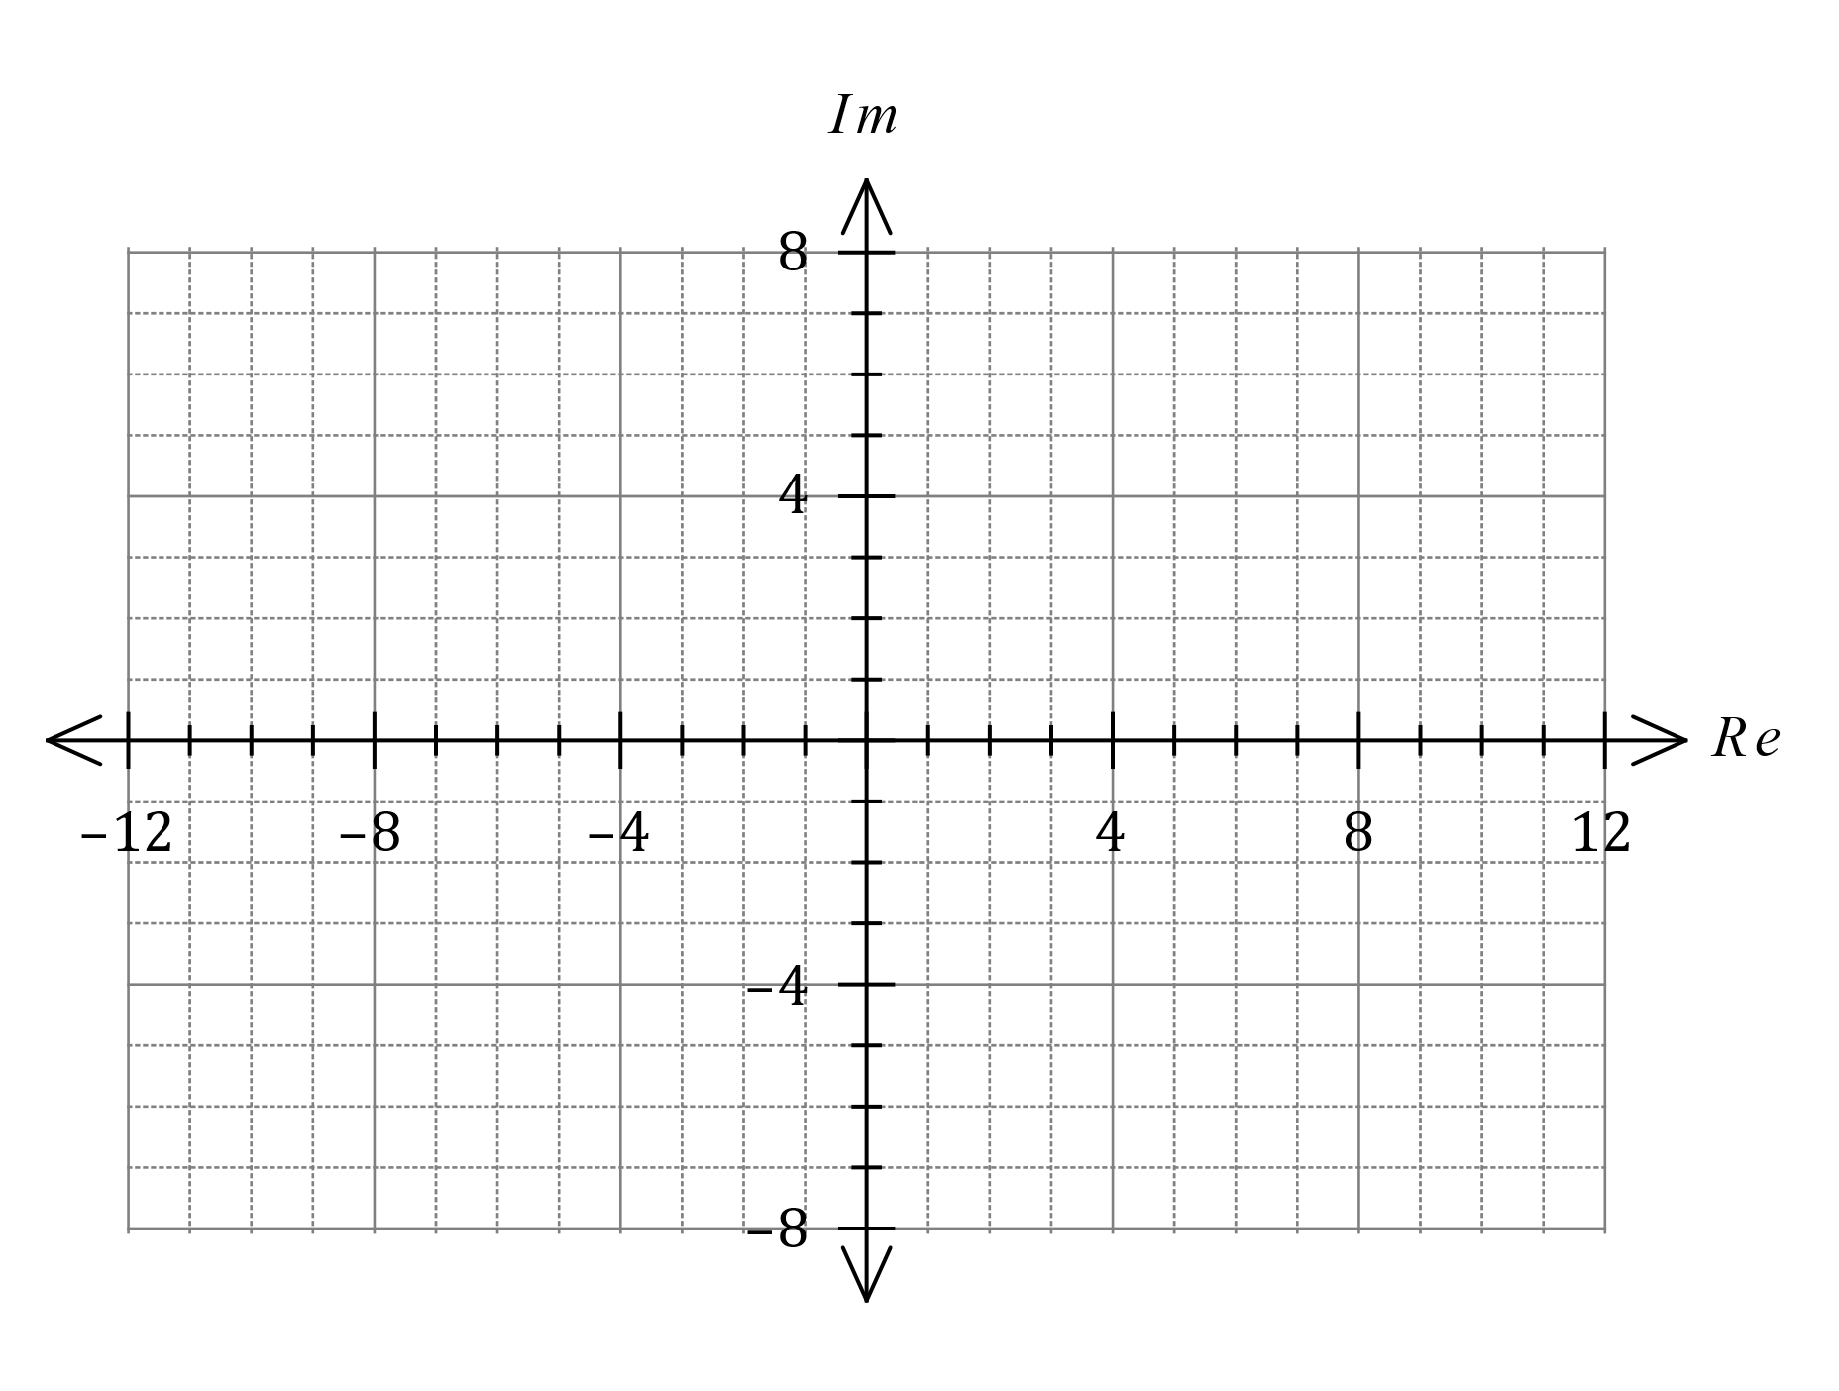

Question 13 (7 marks)

Functions $f$ and $g$ are defined as $f\left(x\right)=\begin{matrix}1 \\ \overline{\sqrt{x+1}}\end{matrix}$ and $g\left(x\right)=e^{x^{2}-1}$.

(a) State the domain of $f(x)$ and explain why $f$ has an inverse. (2 marks)

(b) Determine the defining rule for $f^{-1}(x)$ and state its range. (2 marks)

(c) Determine the defining rule for $g\left(f\left(x\right)\right)$ and state its domain and range. (3 marks)

Question 14 (7 marks)

The position vectors of the points $A$ and $B$ are $r_{A}=\left(\begin{matrix}5 \\ 2 \\ 3\end{matrix}\right)$ and $r_{B}=\left(\begin{matrix}1 \\ -4 \\ 5\end{matrix}\right)$.

(a) Show that if the diameter of sphere $S$ is defined by the line segment $AB$, then the equation of $S=\left|r-\left(\begin{aligned}3 \\ -1 \\ 4\end{aligned}\right)\right|=\sqrt{14}$.

(3 marks)

Straight line $L$ intersects the surface of sphere $S$ at point $A$ and has equation $r=r_{A}+λ\left(\begin{matrix}1 \\ 2 \\ -1\end{matrix}\right)$.

(b) Determine the position vector of $C$, the other point of intersection of $L$ with $S$. (4 marks)

Question 15 (7 marks)

(a) The graph of $y=f(x)$ is shown with a dotted line on the axes below.

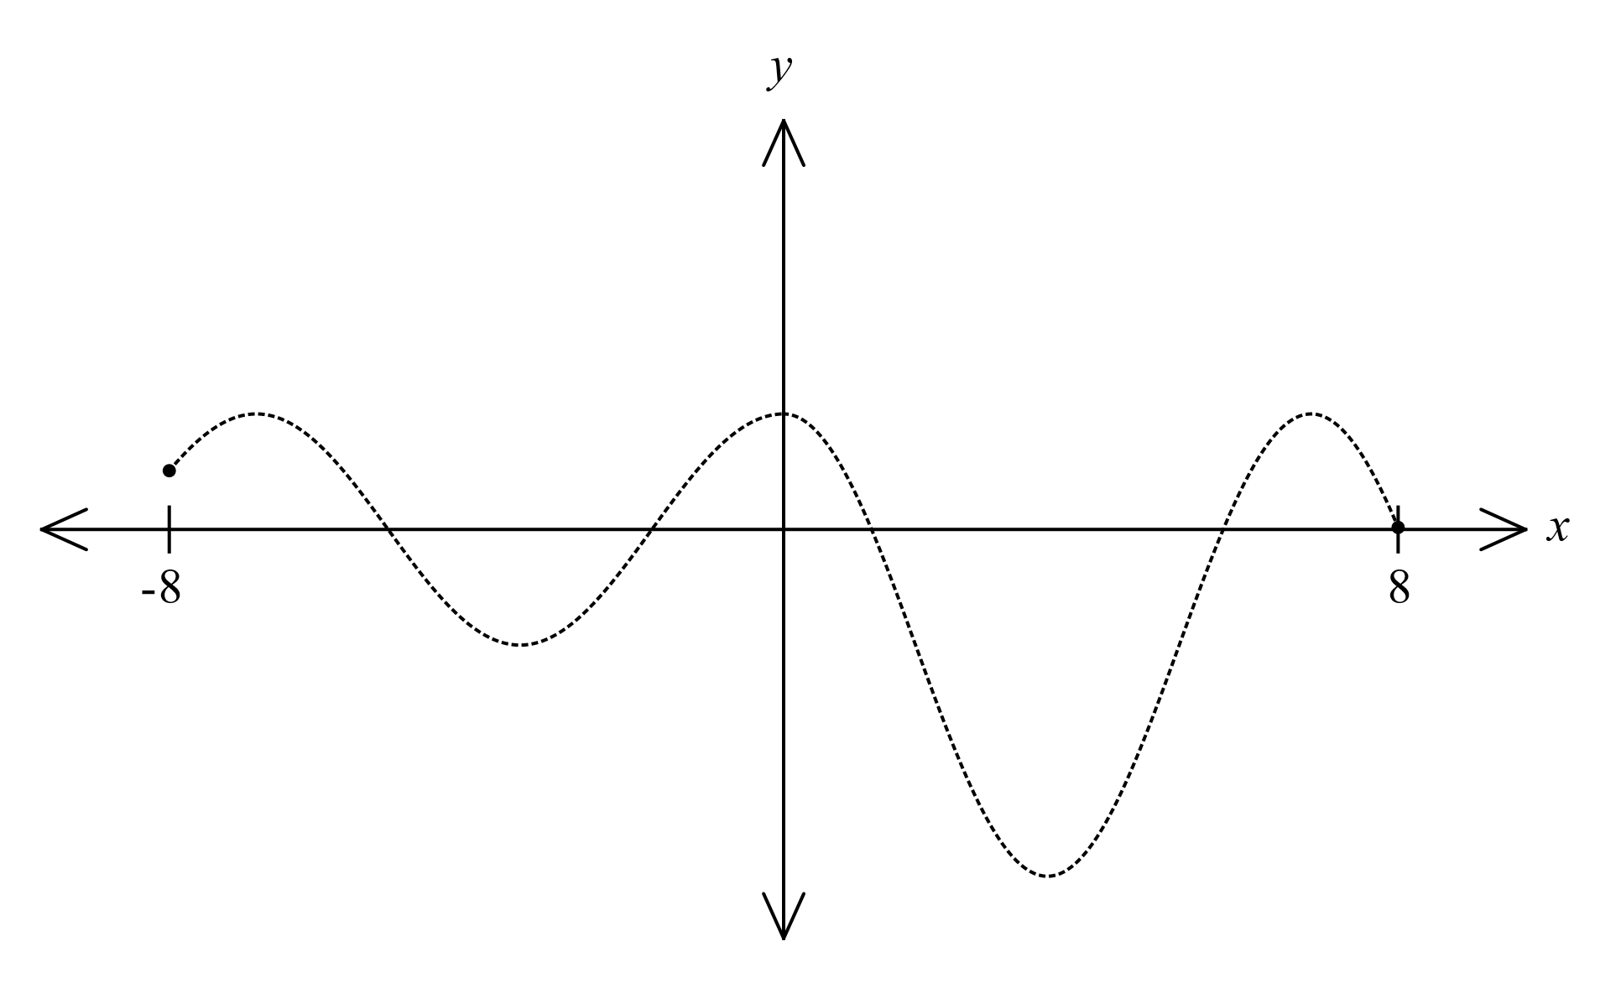

(i) On the same axes, sketch the graph of $y=\left|f\left(x\right)\right|$. (2 marks)

(ii) State the number of roots that the graph $y=f\left(\left|x\right|\right)$ will have. (1 mark)

(b) The graph of $y=g(x)$ is shown with a dotted line on the axes below. Sketch the graph of $y=\begin{matrix}1 \\ \overline{g(x)}\end{matrix}$ on the same axes. (4 marks)

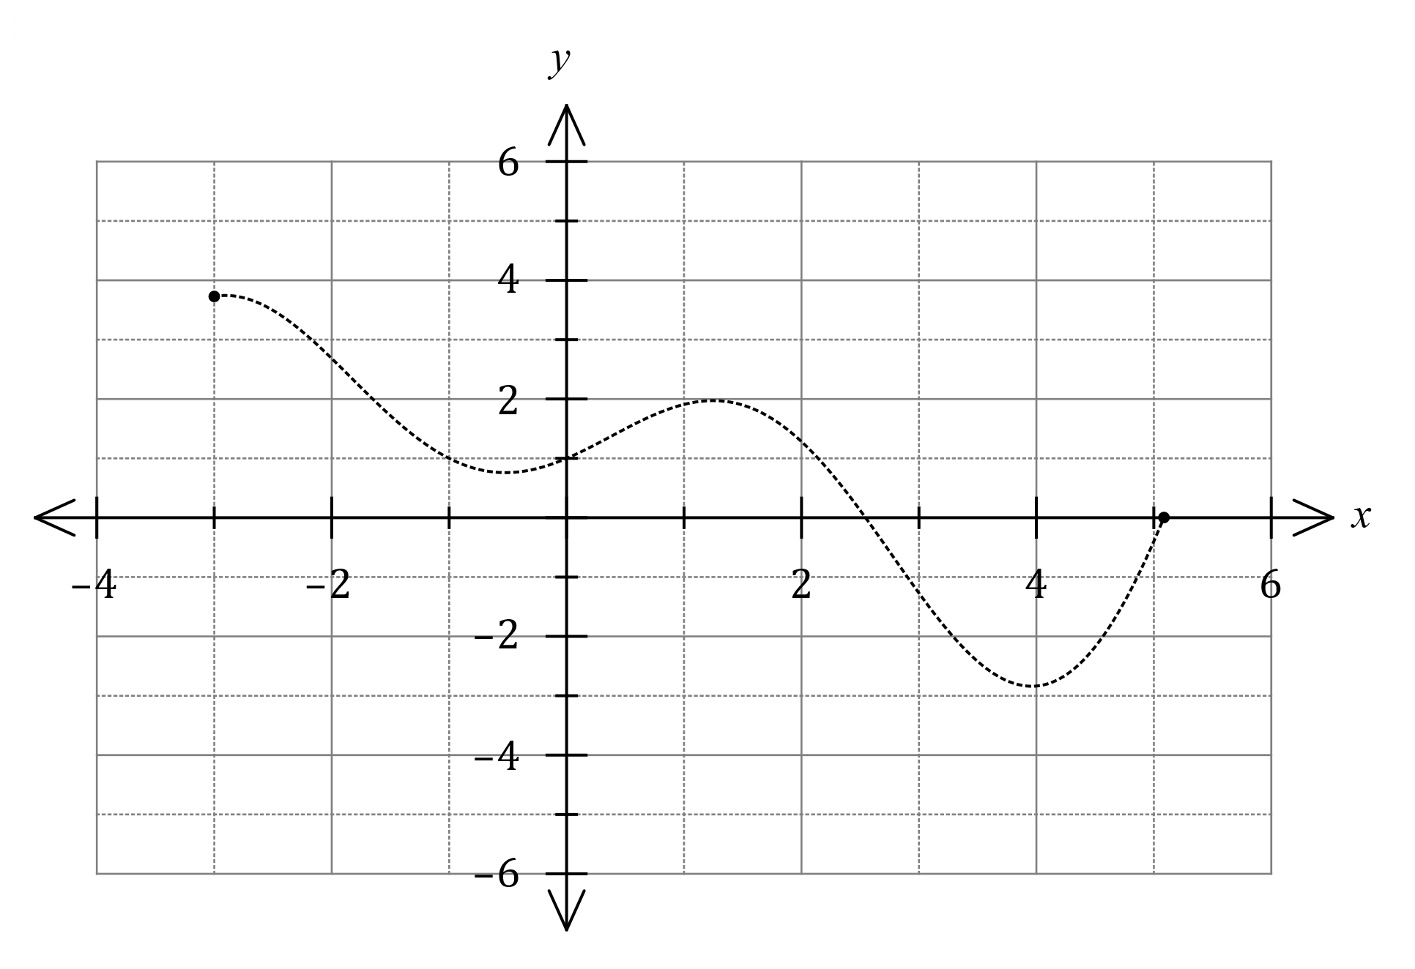

Question 16 (8 marks)

(a) One solution to the equation $z^{3}=u$ is $z=2\operatorname{cis}{(-40°)}$.

(i) Determine the other two solutions, giving solutions in the form $r\operatorname{cis}{θ}$, where $r≥0$ and $-180°<θ≤180°$. (2 marks)

(ii) Determine $u$, giving your answer in the form $a+bi$. (2 marks)

(b) Solve the equation $z^{5}=16\sqrt{2}-16\sqrt{2}i$, giving exact solutions in the form $r\operatorname{cis}{θ}$, where $r≥0$ and $-π<θ≤π$. (4 marks)

Question 17 (8 marks)

Four points in space have coordinates $A\left(5, 4, -5\right), B\left(6, 3, -2\right), C(0, -1, 5)$ and $D(-3, 0, 1)$.

(a) Show that the lines $AC$ and $BD$ intersect and determine the coordinates of their point of intersection. (5 marks)

(b) Determine the Cartesian equation of the plane containing the four points. (3 marks)

Question 18 (6 marks)

(a) The graph of $y=\left|f\left(x\right)\right|$ is shown below, where $f\left(x\right)=ax^{3}+bx^{2}+cx-9$. Determine the value of each of the coefficients $a, b$ and $c$. (3 marks)

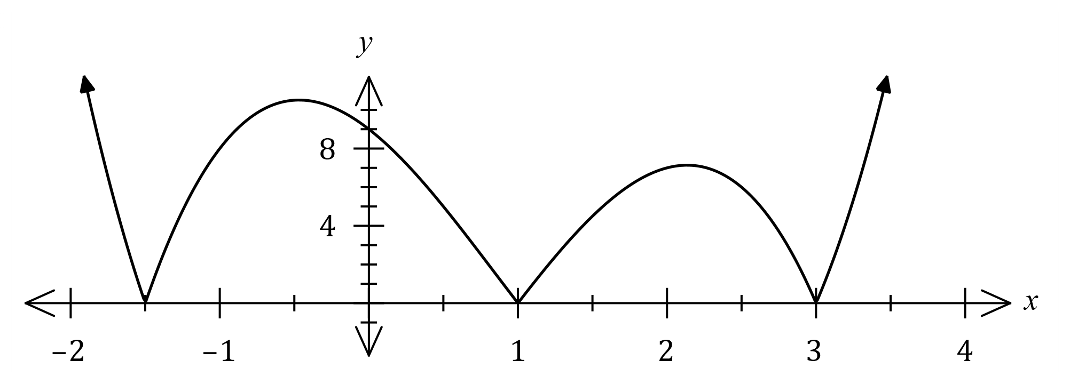

(b) The graph of $y=\left|px\right|+\left|x+q\right|+r$ is shown below, where $p, q$ and $r$ are constants.

(3 marks)

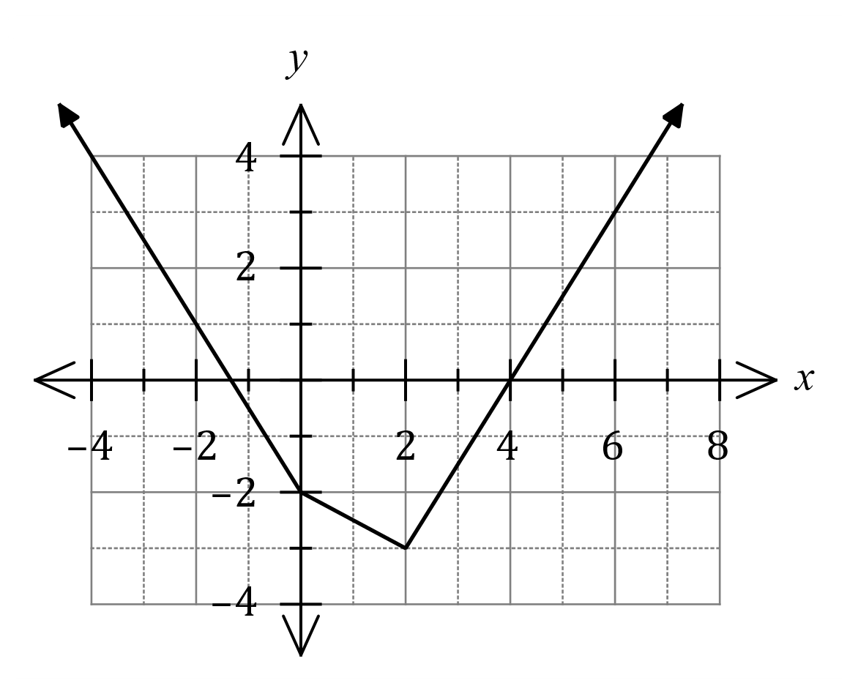

1. Describe how the graph above indicates that the gradient of $\left|px\right|$ changes at $x=0$.
2. Determine $p, q$ and $r$.

Question 19 (8 marks)

The position vector of a particle at time $t$ seconds is given by $r\left(t\right)=\left(\begin{matrix}5 \sin^{2}{(t)}-2 \\ 2\cos{t}\end{matrix}\right)$ cm.

The path of the particle is shown below, together with the points $A(-2, 2)$ and $B(3, 0)$ that lie on its path.

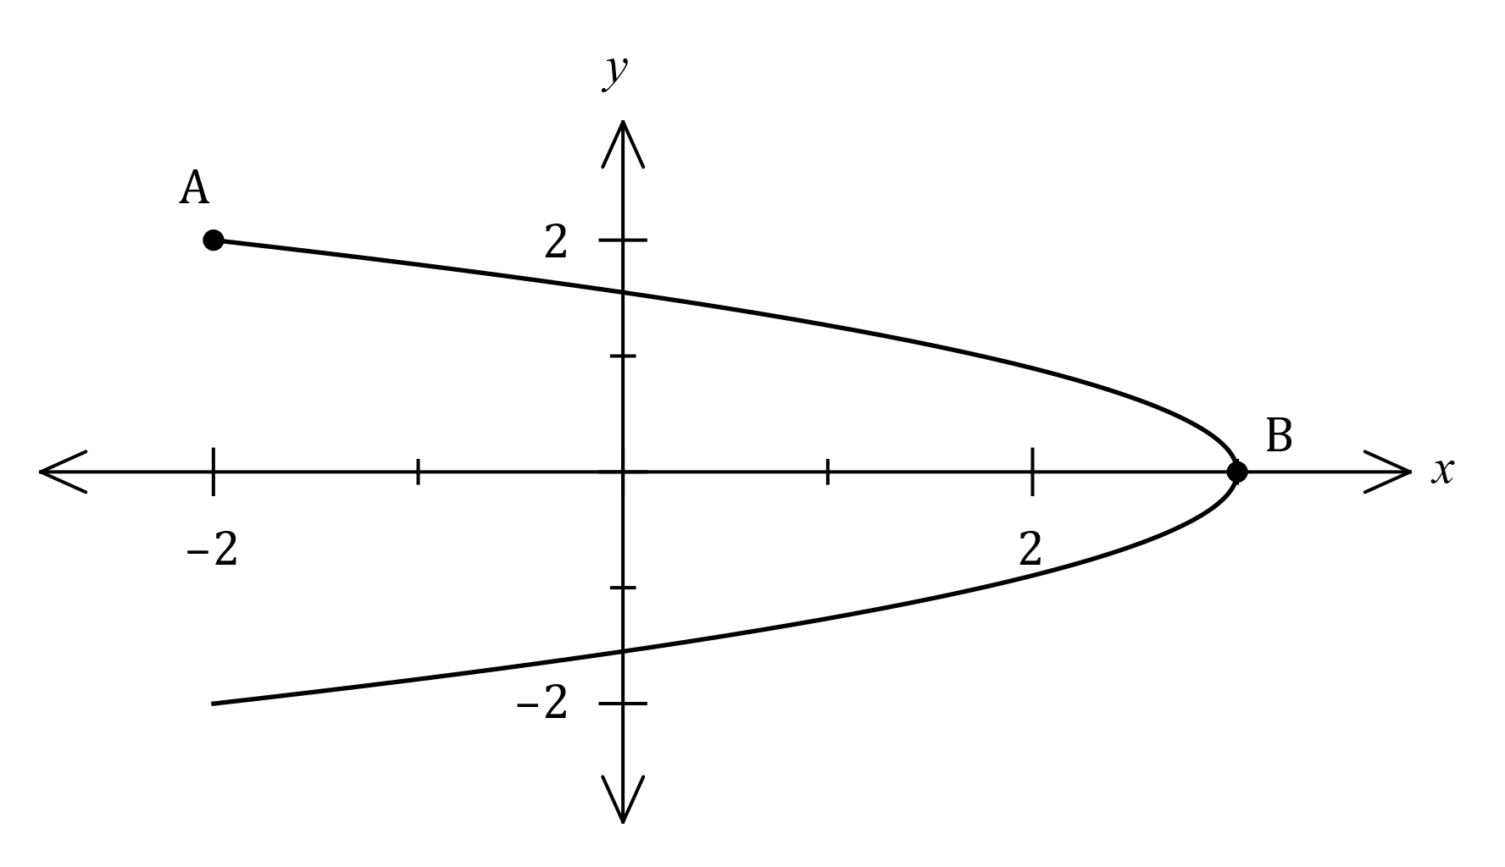

(a) Express the path of the particle as a Cartesian equation. (3 marks)

(b) Determine the velocity of the particle when $t=\frac{π}{4}$. (2 marks)

(c) Determine the distance travelled by the particle as it moves from $A$ to $B$. (3 marks)

Question 20 (6 marks)

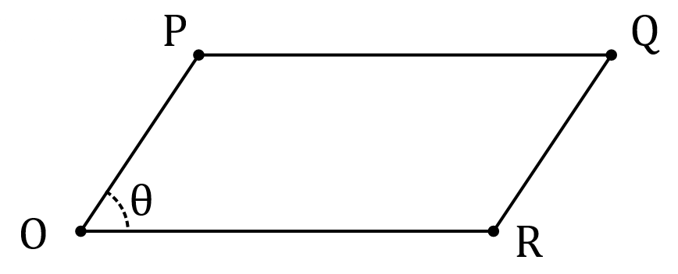In the parallelogram shown, $\vec{OP}=p$, $\vec{OR}=r$ 
and the angle between the  
directions of $p$ and $r$ is $θ$.

It can be shown that $\left|p×r\right|=\left|p\right|\left|r\right|\sin{θ}$.

(a) Explain why evaluating $\left|p×r\right|$ will result in the area of the parallelogram. (2 marks)

The area of is cm2 when the position vectors of $O, P$ and $Q$ are $\left(\begin{matrix}0 \\ 0 \\ 0\end{matrix}\right), \left(\begin{matrix}a \\ -2 \\ 1\end{matrix}\right)$ and $\left(\begin{matrix}3 \\ -2 \\ -1\end{matrix}\right)$ respectively, with units in centimetres.

(b) Determine the value(s) of the constant $a$. (4 marks)

Question 21 (7 marks)

Let the complex number $z=\sqrt{3}+i$ and the function $f$ be defind as $f\left(n\right)={(z)}^{n}-{(\overline{z})}^{n}, n∈Z$.

(a) Determine the modulus and argument of $f(-1)$. (2 marks)

(b) Use De Moivre's theorem to determine all values of $n$ for which $f\left(n\right)=0$. (5 marks)

Supplementary page

Question number: _________

Supplementary page

Question number: _________

© 2021 WA Exam Papers. Mandurah Catholic College has a non-exclusive licence to copy and communicate this document for non-commercial, educational use within the school. No other copying, communication or use is permitted without the express written permission of WA Exam Papers. SN192-174-2.